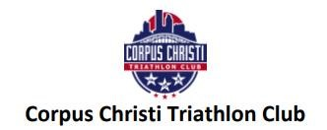
Dear Potential Sponsor:
The Corpus Christi Triathlon Club (a 501(c)(4) organization) would like to invite you and your business to become a 2024 Club Sponsor. Our club has been a leader in promoting healthy, active lifestyles in the Coastal Bend for over 20 years. We host local triathlon events, offer free training clinics to the community, and raise awareness and contributions for multiple local charities, including Bikes for Kids and Colin’s Hope.
This year, our primary focus is to increase our outreach by developing youth triathlon talent and bridging the gap between triathlon and other athletic organizations. Our annual membership has grown rapidly over the past year, and we currently serve approximately 120 members. We have an increasing social media presence that reaches over 1,000 Facebook followers and a growing number of followers on Instagram.
Triathletes are often highly motivated, successful individuals with positive attitudes and a strong influence on their peers. In terms of marketing value, they are an ideal segment because of their life station and community involvement. Our club, however, cannot support these individuals to positively influence our community without the support of partners like you.
To meet these goals, we promote four levels of sponsorship with the following benefits:
We hope you will consider supporting the Corpus Christi Triathlon Club as we pursue our goals of spreading an appreciation of the multi-sport lifestyle and promoting healthy, active lifestyles in Corpus Christi and Coastal Bend.
Thank you for your consideration.
For more information, please contact:
Johnathan Rhoads, President Joaquin Rodriguez, VP Dr. Annie Quysner, Secretary
850.207.2972 361-739-1624 361.877.3417
Rhoads.johnathan@yahoo.com Joaq.rodriguez@yahoo.com aquysner@gmail.com
Dawn Prebula, Accountant Eddie Garcia, Membership
301.247.5215 361.232.8789
Dawnprebula@yahoo.com eegrc31@aol.com
Iron Level Sponsor- $1,000, plus a minimum of a 10% discount on products/services for CCTC members (if applicable).
- All Iron level benefits plus the following:
- Large logo on Corpus Christi Triathlon Club team kit and 2023 DriFit tee given to all members
- Opportunity to be a Guest Presenter at one monthly club meeting
- Opportunity to contribute content to bi-weekly club newsletter
- One Monthly Facebook Post (with visibility to 1000+ friends) regarding your business as a sponsor or to highlight your product or services
- Race Event Benefits: Large logo on all race shirts / Advertisements in all race packets / Banner space at all races / Display or booth space at all race packet pick up or race venue / Verbal recognition during all races / 2 complimentary race entries.

Half-Iron Level Sponsor- $500, plus a minimum of a 10% discount on products/services for CCTC members (if applicable).
- All Half-Iron level benefits plus the following:
- Medium logo on Corpus Christi Triathlon Club team kit
- Two Annual Memberships for the CC Tri Club (over $70 value)
- Two complimentary tickets to the annual Triathlon Club Holiday Party
- Race Event Benefits: Medium logo on all race shirts / Advertisements in all race packets / Banner space at all races / Display or booth space at all race packet pick up or race venue / Verbal recognition during all races / 2 complimentary race entries.

Olympic Level Sponsor- $250, plus a minimum of a 10% discount on products/services for CCTC members (if applicable).
- All Olympic level benefits plus the following:
- Banner Space at all CC Tri Club Training Sessions (Approx. 10X per year)
- Logo on Club T-Shirt • One Annual Memberships for the CC Tri Club (over $35 value)
- Race Event Benefits (one event): Medium logo on race shirt / Advertisements in race packet / Banner space at race venue / Display or booth space at race packet pick up or race venue / Verbal recognition during race / 1 complimentary race entry.

Sprint Level Sponsor - $125, plus a minimum of a 10% discount on products/services for CCTC members (if applicable).
- Mention at each club meeting and speaker event
- Listing on our sponsor page on the Triathlon Club website
- Verbal Recognition at all Club Meetings
- Race Event Benefits (one event): Small logo on race shirt / Advertisements in race packet.

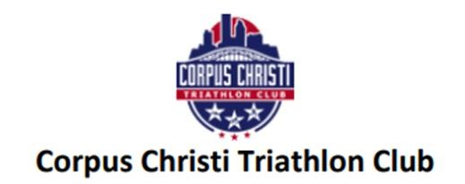

Contact Name:

Contact Email Address:

Contact Phone Number:

Name of Organization (how you would like to be recognized):

Sponsorship Level (indicate one):
__ Iron ($1,000)
__ Half-Iron ($500)
__ Olympic ($250)
__ Sprint ($125)
Instructions: Please fill out the above form and include a check payable to “Corpus Christi Triathlon
Club.”
This form should be mailed to:
Corpus Christi Triathlon Club c/o Johnathan Rhoads
6522 Purplewing Dr
Corpus Christi, TX 78414
Please also send a logo (preferably in .png or .jpg format) via email to rhoads.johnathan@yahoo.com that we may use on our website and include in additional materials. Thank you for your support of our club!

