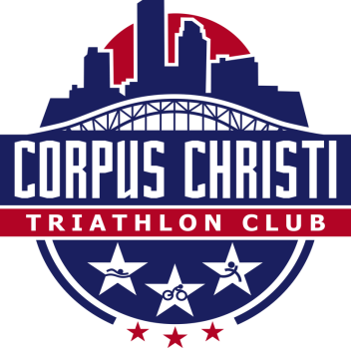

Dear Prospective Sponsor:

On behalf of the Corpus Christi Triathlon Club (formerly known as STARRS: South Texas Runners, Riders, and Swimmers), I am pleased to invite you to sponsor our Annual Multi-Sport events for 2015, which will be held at various locations in Corpus Christi and surrounding areas. The Corpus Christi Triathlon Club (CCTC) is currently planning at least three major events this year. This year we are offering annual as well as event specific sponsorship opportunities.

Your sponsorship of our club race events will support efforts to offer fun and challenging sporting activities to the community including Triathlon, Duathlon, Cycling, Running and Swimming. We also strive to set a good example of safe, positive, eco-friendly, and healthy activities for a wide range of participants. Each event has a designated local beneficiary. CCTC has provided low-income children with more than hundreds of bicycles and helmets over the past 10 years and has donated thousands of dollars to various community organizations such as CASA, South Texas Children’s Home, Women’s Advocacy Center, Lake Corpus Christi State Park and the Boy Scouts.

Your business name and logo will be seen and appreciated by hundreds of participants and supporters before, during and after each event. At each sponsorship level we are able to provide increasing marketing opportunities to you and your business. For example your name or logo will appear on printed items such as shirts, posters and other signage; you may place marketing material in the event packets and /or place your banner at the event location. Your business may also have web exposure on the swimbikeruncc.com website. Please see the attached sponsor sheet for more specific details. We are happy to receive cash or “in kind” donations of products or services. Remember, your sponsorship, thus name association continues throughout the year.

Not only would we encourage you to be a sponsor of this and our other events, we invite you to participate and learn more about the USA Triathlon (USAT) organization and CCTC. For more information, please visit the website www.usat.com or http://www.swimbikeruncc.com/. If you have any further questions, please contact me: alf_martinez11@yahoo.com. The deadline for recognition in printed information is one week prior.
Please complete the attached sponsor info sheet and forward with a print-ready image file (jpeg, .gif, .tif) file with your desired name or logo, and a link for the webpage if desired, to Attn: Freddy Martinez, email alf_martinez11@yahoo.com Thank you for your consideration and I look forward to hearing from you soon.
Sincerely

Freddy Martinez
CCTC Sponsor

